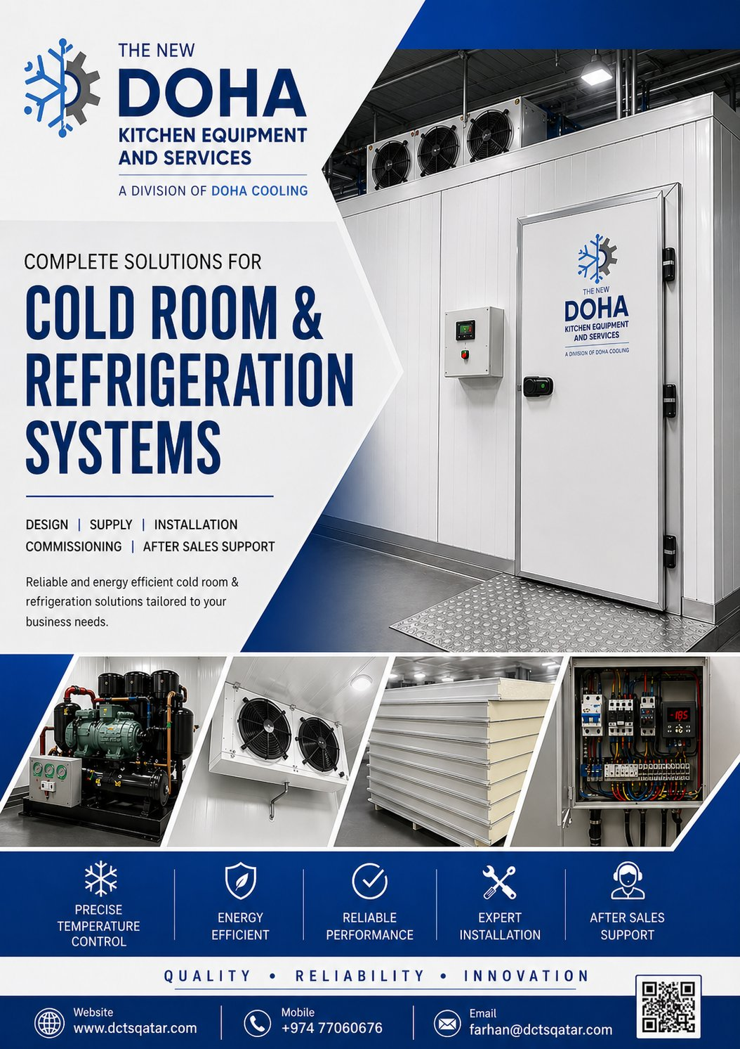

TNDK | The New Doha Kitchen  Equipment Services W.L.L.  P.O. Box 80247, Doha – Qatar  info@dkeqatar.com
QUOTATION
REFERENCE | DATE | VALIDITY
QUT/DCTS/068/2026 | 13 October 2026 | 15 Days from quote date

TO | FROM
M/s. Midas  Doha, Qatar  Attn: Mr. Premjith | The New Doha Kitchen Equipment Services W.L.L.  P.O. Box 80247, Doha – Qatar  Email: farhan@dctsqatar.com  Prepared by: Farhan – Sales Engineer
Subject: Re-erection of Chiller Room (10.20 × 4.00 × 2.50 m) using Existing Panels & Existing Refrigeration Machine — with Additional Panels, New Sliding Door, Control Panel & Complete Accessories
Dear Sir, with reference to the above subject, we thank you for the opportunity to quote for your chiller room project. Please find below our detailed technical and commercial offer for the re-erection of a 10.20 × 4.00 × 2.50 m chiller room using your existing insulated panels and existing refrigeration machine, together with the supply and installation of additional panels, a new sliding cold room door, a new control panel box and complete installation accessories, including testing and commissioning.

Project description:
ROOM TYPE | QTY | TEMPERATURE | EXTERNAL DIMENSIONS | PANEL THICKNESS
CHILLER | 1 | +2°C to +8°C | 10.20 × 4.00 × 2.50 m | 100 mm (to match existing)

1. PANEL DETAILS
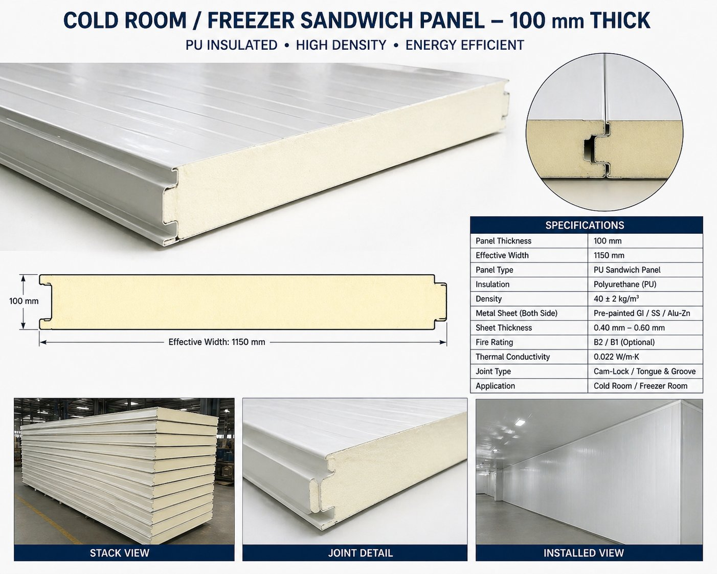
Panel Type | Pre-insulated Polyurethane (PUF) Sandwich Panel
Panel Thickness | 100 mm — new panels to match existing panels (thickness to be confirmed at site survey)
Insulation Core | CFC-free injected polyurethane foam, density 40 ± 2 kg/m³
Skin Material | 0.5 mm pre-painted galvanized steel (PPGI), food-grade white
Locking System | Cam-lock / Hook-lock type for tight, leak-proof joints
Thermal Conductivity (k) | 0.022 W/m·K (typical)
Fire Rating | Class B / Self-extinguishing
Wall Coverage | 2 × (10.20 × 2.50) + 2 × (4.00 × 2.50) = 71.00 sqm (perimeter run 28.40 m)
Ceiling Coverage | 10.20 × 4.00 = 40.80 sqm (4.15 m panels spanning the 4.00 m width)
Floor Coverage | Not applicable — chiller installed on existing floor (no insulated floor)
Total Panel Quantity | Required: 111.80 sqm | Existing (client) panels re-used: 85.95 sqm | New panels supplied by TNDK: 41.57 sqm
Existing Panels (Client) | 285 × 102 cm – 20 pcs | 285 × 54 cm – 2 pcs | 285 × 48 cm – 1 pc | 415 × 102 cm – 5 pcs | 415 × 53 cm – 1 pc (Total 29 pcs; 2.85 m wall panels trimmed to 2.50 m on site)
Additional Panels (TNDK) | 2.50 m × 1.02 m – 8 pcs (walls) | 4.15 m × 1.02 m – 5 pcs (ceiling) | Total 13 pcs
Coverage Check | Walls: 23 existing + 8 new = 30.12 m panel run vs 28.40 m perimeter ✓ | Ceiling: 6 existing + 5 new = 10.73 m vs 10.20 m room length ✓
2. DOOR DETAILS
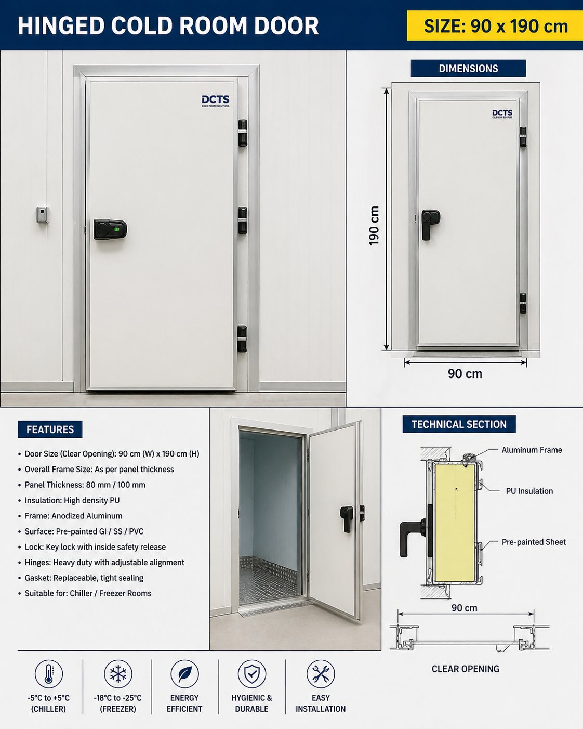
Door Type | Sliding Cold Room Door (single leaf, manual operation)
Clear Opening Size | 1500 mm (W) × 2000 mm (H)
Door Thickness | 100 mm — insulated PUF leaf, matching wall panel
Frame | Heated PVC/Aluminum anti-condensation frame
Track & Rollers | Heavy-duty top-hung sliding track with rollers, floor guide and end stoppers
Handle / Lock | Pull handle with lock provision and internal safety release (anti-trap)
Gasket | Magnetic / silicone double gasket, food-grade
Quantity | 1 (one) No. — new
3. ANGLES, SILICONE & ACCESSORIES
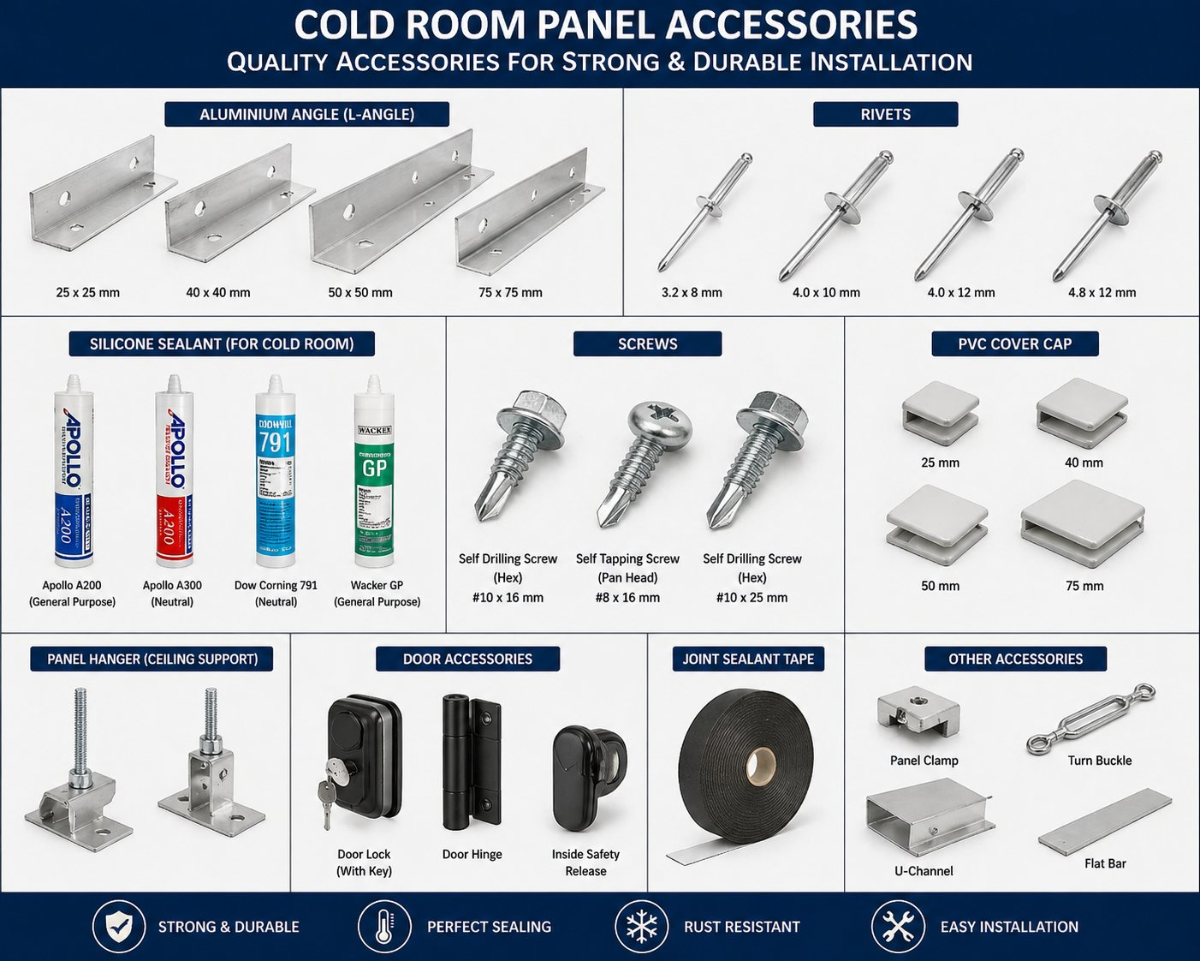
Internal Coving | Aluminum sanitary coving at all wall–floor and wall–ceiling joints
External Trim | Aluminum corner angles / capping at all external corners
Sealants | Food-grade neutral-cure silicone sealant at all panel joints, door frame and floor seam
PU Foam | Expanding polyurethane foam for joint backing
Fasteners | Stainless steel rivets, screws and washers
Vapor Sealing | Continuous vapor barrier at panel–floor interface
4. FLOORING DETAILS
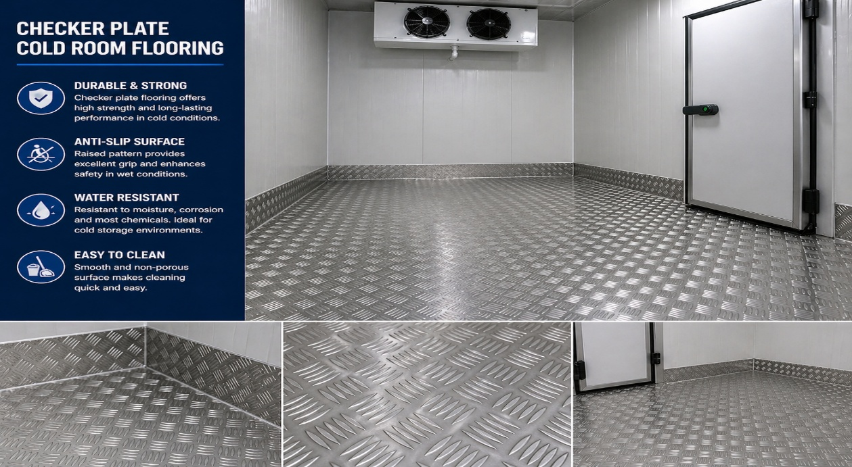
Insulated Floor Panel | Not included — chiller to be erected on the existing level floor
Plywood Layer | Not included
Top Finish | Existing floor finish (by client)
Edge Sealing | Aluminum floor U-channel / coving at wall-panel base with silicone seal
Load Suitability | Subject to existing floor condition
5. REFRIGERATION MACHINE DETAILS
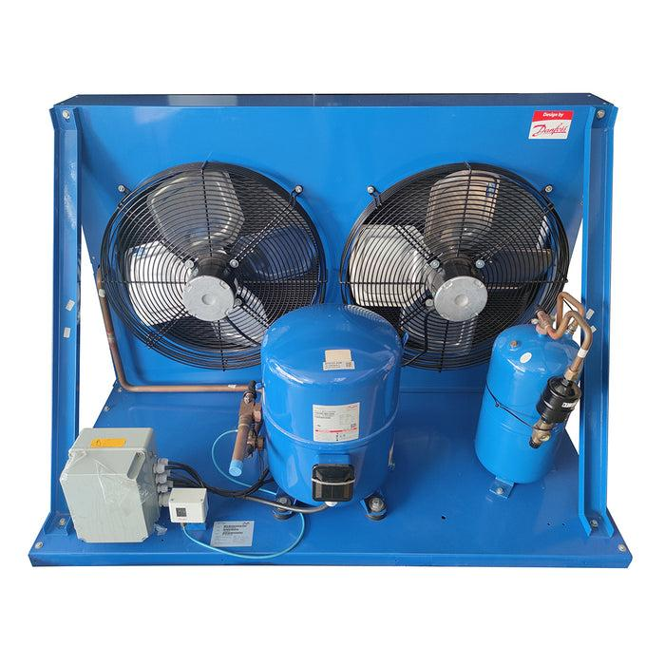  Condensing Unit (Outdoor) |  | 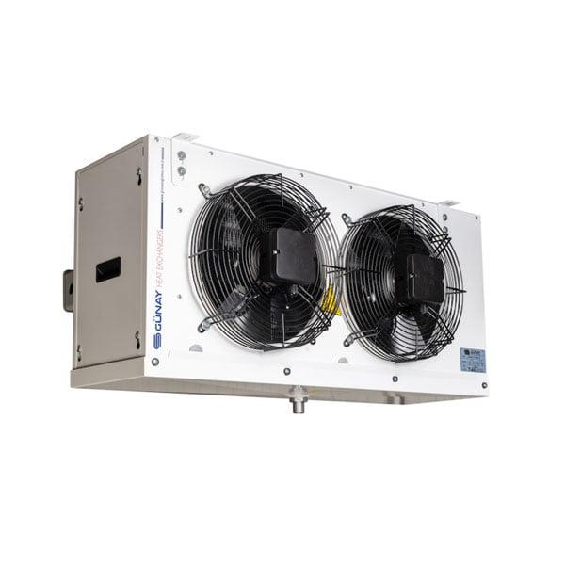  Evaporator / Air Cooler (Indoor)
System Type | Split-type refrigeration system — client's EXISTING machine (1 set), shifted and re-installed by TNDK
Condensing Unit | Existing — Model AUH 405 CS (client supplied)
Machine Condition | Existing unit re-used: general service, leak check and inspection before re-commissioning. Condition and capacity of the existing machine remain the client's responsibility.
Refrigerant | As per existing unit nameplate — refrigerant charging included
Evaporator (Air Cooler) | Existing — Model F31HC235E_6 (client supplied), ceiling-mounted inside the chiller
Mounting | Evaporator ceiling-suspended inside the room; condensing unit on outdoor pad
Operating Temperature | Chiller: +2°C to +8°C
Defrost | As per existing evaporator, controlled from the new control panel
Drain Line | Insulated drain line with heating tape (where exposed)
6. MACHINE CAPACITY (HEAT LOAD)
Internal Volume | 10.20 × 4.00 × 2.50 = 102 m³ (external)
Design Ambient | +45°C (Doha summer condition)
Design Room Temp. | Chiller: +4°C
Estimated Heat Load | Approx. 6.0 – 7.5 kW (indicative, for a 102 m³ chiller at +45°C ambient; final load depends on product quantity and door openings)
Selected Capacity | Existing condensing unit AUH 405 CS with evaporator F31HC235E_6 to be used. TNDK will check the nameplate capacity against the estimated load at site survey and advise of any shortfall before installation.
Run Time | Designed for ≤ 16 hours/day operation
Power Supply | 415 V / 3-Phase / 50 Hz (or 230 V / 1-Phase as confirmed at site)
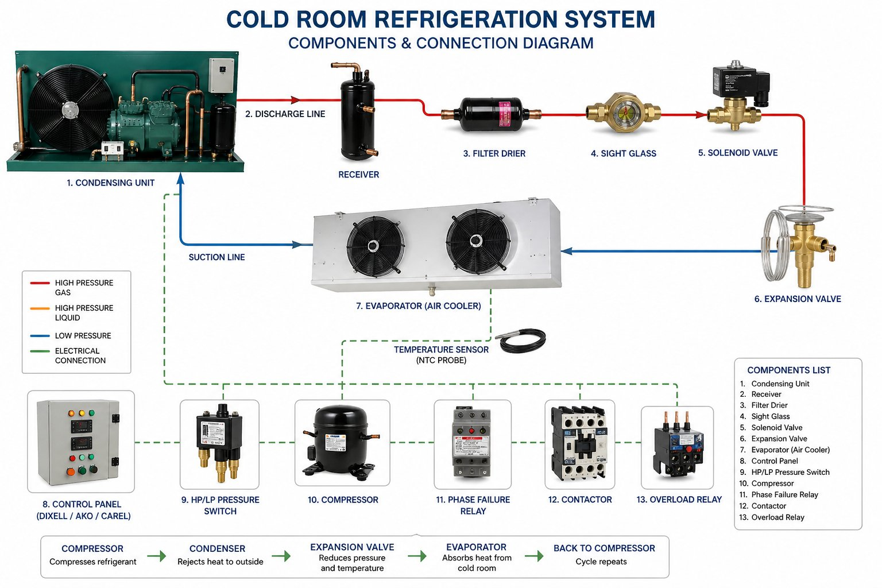
Refrigeration system components & connection schematic — for reference.
7. CONTROL PANEL DETAILS
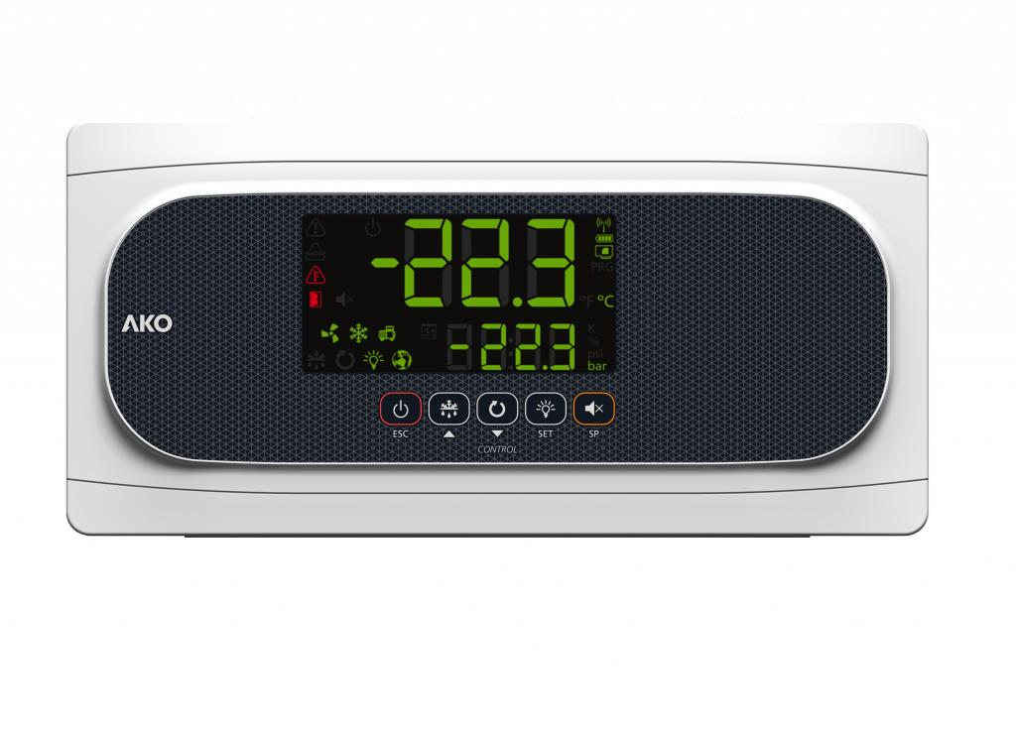  Digital Temperature Controller |  | 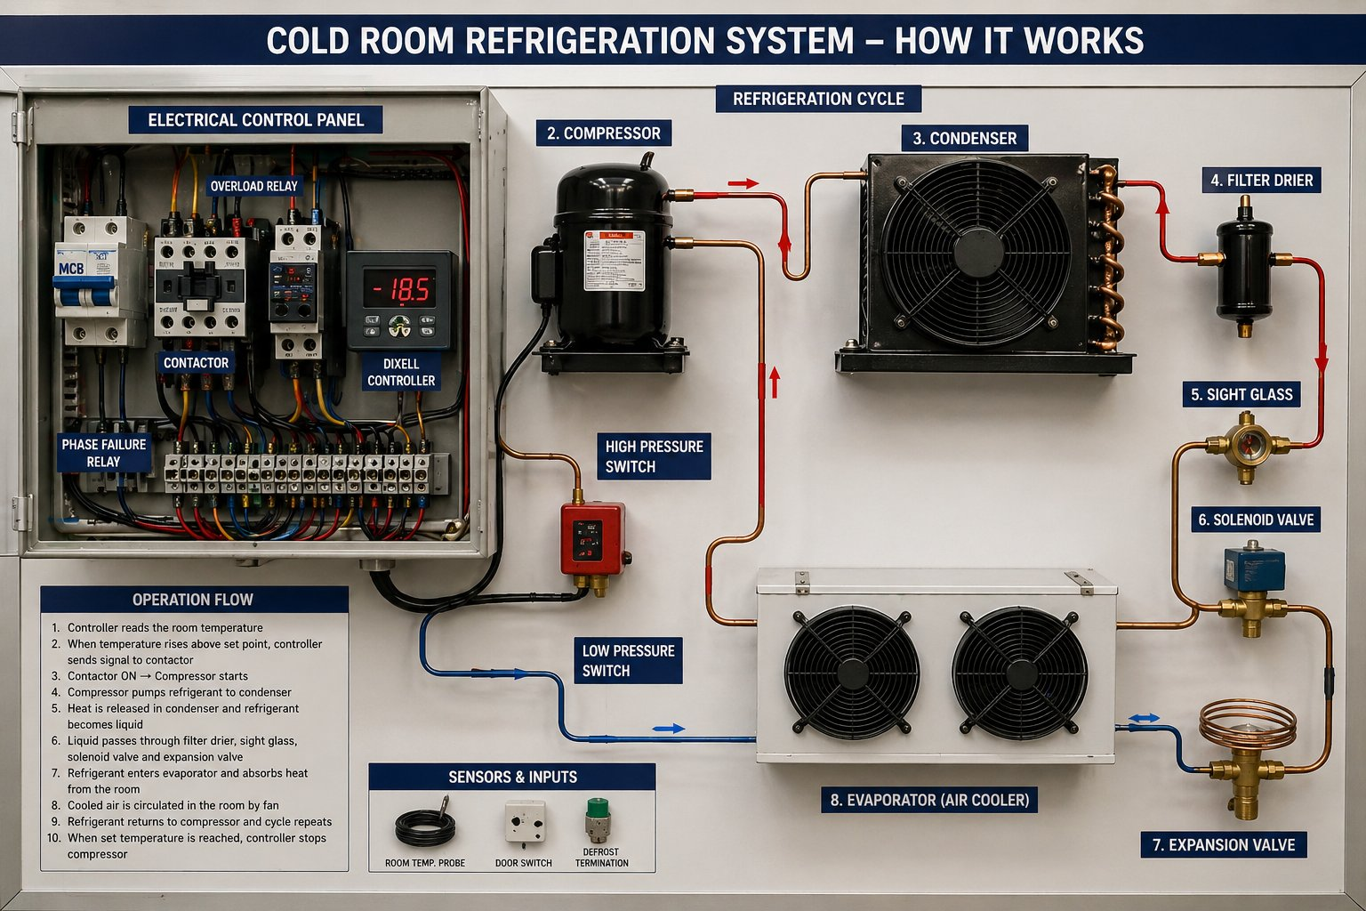  Typical Wiring Schematic
Controller | Eliwell / Dixell / Carel digital temperature controller
Display | Digital LED display showing set point and actual room temperature
Functions | Compressor ON/OFF, evaporator fan control, electric defrost timer, alarm output
Protections | Overload relay, phase-failure relay, HP/LP cut-out switches
Indicators | Power-ON, Compressor-ON, Defrost, Alarm pilot lamps
Safety | MCB, contactors and emergency stop in metallic enclosure (IP54)
Door Frame Heater | Anti-condensation heater wired through control panel
Internal Light | Vapor-proof LED light inside the room with ON/OFF switch outside
8. SCOPE OF WORK
- Site survey, inspection of existing panels and machine, and confirmation of final room dimensions.
- Dismantling (where erected), shifting within site, cleaning and trimming of client's existing panels (29 pcs) to 2.50 m height, and re-erection.
- Supply and installation of additional 100 mm PUF panels: 2.50 m – 8 pcs (walls) and 4.15 m – 5 pcs (ceiling).
- Supply and installation of one (1) No. new sliding cold room door, 1500 × 2000 mm clear opening.
- Disconnection, shifting and re-installation of client's existing condensing unit (AUH 405 CS) and evaporator (F31HC235E_6), including general service.
- New refrigeration copper piping, armaflex insulation, filter drier, sight glass and insulated drain line, with refrigerant charging.
- Electrical works from the cold room control panel onward — including power, control wiring, internal LED light, door frame heater and emergency switch.
- Supply and mounting of new digital control panel box with all safeties.
- Supply of complete accessories — aluminum coving, corner angles, floor U-channel, silicone, PU foam, rivets and fasteners — with full vapor sealing.
- Pressure testing, vacuum, gas charging, testing and commissioning.
- Handover with operation training and as-built documentation.
9. EXCLUSIONS
- Civil works, foundation, leveling and any structural support.
- Power supply (Main DB), main cable run from MDB to cold room control panel.
- Any false ceiling removal, modifications or restoration of existing finishes.
- Drain piping beyond 3 m from the evaporator drain outlet.
- Backup power, UPS, generator or stabilizer.
- Telephone, CCTV, BMS or IoT integration (available on request — separately quoted).
- Any taxes, duties or municipality fees other than those explicitly mentioned.
- Lifting equipment / cranes if access requires more than standard manual handling.
- Working at heights above 3 m (additional scaffolding cost shall apply).
- Insulated floor, floor panels or floor finish works.
- Replacement of damaged existing panels, or repair / spare parts / compressor replacement for the existing refrigeration machine — if found necessary during inspection, these will be quoted separately.
- Any item not specifically listed in the Scope of Work.
10. PRICING / BILL OF QUANTITIES
SL# | Description (Size & Quantity) | Amount (QAR)
1 | Re-erection of chiller room 10.20 m × 4.00 m × 2.50 m (102 m³) using client's existing panels (29 pcs — dismantling, shifting, trimming to 2.50 m and re-erection), plus supply & installation of additional 100 mm PUF panels: 2.50 m – 8 pcs and 4.15 m – 5 pcs (41.57 sqm). | 12,000.00
2 | Supply & installation of one (1) No. new sliding cold room door, clear opening 1500 × 2000 mm, 100 mm thick, with heavy-duty track, rollers, door heater, pull handle and inside safety release. | 7,000.00
3 | Supply & installation of complete accessories: aluminum coving, corner angles, floor U-channel, food-grade silicone, PU foam, rivets, fasteners and full vapor sealing. | 2,500.00
4 | Disconnection, shifting & re-installation of client's existing refrigeration machine (Condensing unit AUH 405 CS + Evaporator F31HC235E_6) with general service, new copper piping, armaflex insulation, filter drier, sight glass, insulated drain line and refrigerant charging. | 5,000.00
5 | Supply & installation of new digital control panel box with all safeties, internal LED lights, door heater wiring and complete electrical works from control panel onward. | 4,500.00
6 | Testing, commissioning, transportation, mobilization, lifting at site and handover with operation training. | 2,000.00

GRAND TOTAL (Lump Sum) | QAR 33,000.00
Amount in Words: Qatari Riyals Thirty Three Thousand Only.

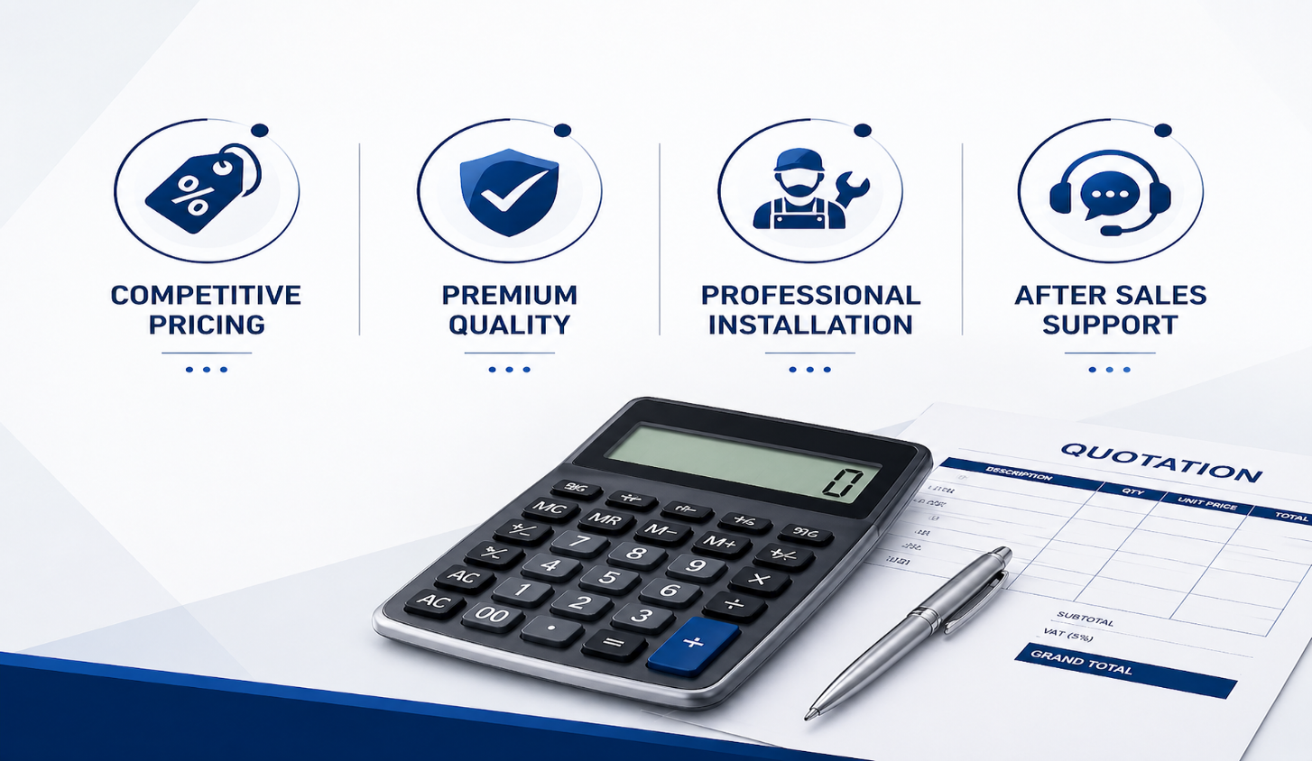

11. WARRANTY
Cold Room Panels & Door | New panels & new sliding door: 12 months from handover against manufacturing defects. Existing re-used panels: workmanship only
Refrigeration Compressor | Existing machine — not covered (client's re-used equipment); TNDK re-installation workmanship: 12 months
Evaporator & Condenser Coils | Existing — not covered under warranty
Electrical Components & Controls | New control panel & electricals: 12 months from date of commissioning
Workmanship | 12 months from date of handover
Warranty Exclusions | Damage due to misuse, power surge, improper voltage, water ingress, unauthorized modification or absence of routine maintenance
12. DELIVERY & WORK COMPLETION
Material Delivery | 2 – 3 weeks from date of LPO and approved advance payment (sliding door lead time)
Site Mobilization | Within 3 working days of material arrival at site
Installation Period | 5 – 6 working days for a civil-ready site
Testing & Commissioning | 1 – 2 working days after installation completion
Total Project Duration | Approx. 3 – 4 weeks from LPO (subject to site readiness)
Working Hours | Standard working days, 08:00 – 17:00 (extended hours billed separately)
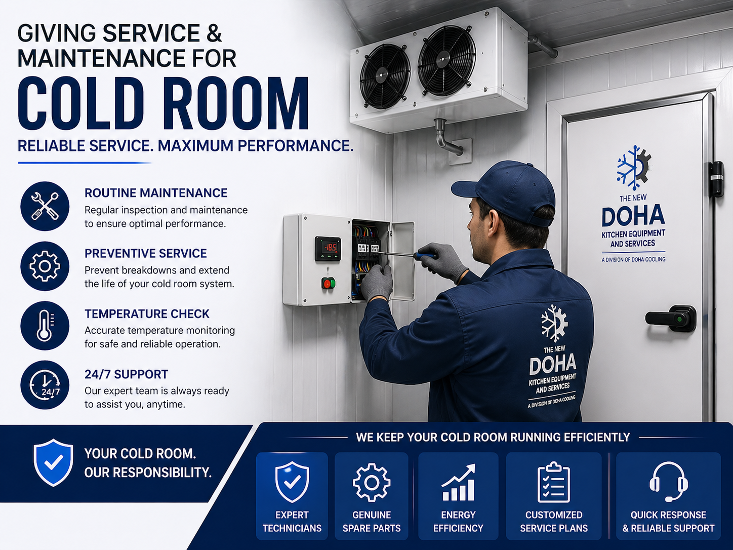
13. PAYMENT & COMMERCIAL TERMS
- 50% advance payment along with confirmed Local Purchase Order (LPO).
- 40% on delivery of materials at site.
- 10% balance after successful testing, commissioning and handover.
- Payment by cheque / bank transfer in favor of The New Doha Kitchen Equipment Services W.L.L.
- Prices are quoted in Qatari Riyals (QAR) and are exclusive of VAT, if applicable.
- This quotation is valid for 15 days from the date of issue.
We trust that the above offer meets your requirements and look forward to your favorable response. Should you require any further clarification or technical detail, please do not hesitate to contact us.
Thank you for the opportunity.
Best Regards,
Farhan
Sales Engineer
The New Doha Kitchen Equipment Services W.L.L & Doha Cooling Trading & Solutions W.L.L
Email: farhan@dctsqatar.com

